**CHILTERN FLY TYING & FLY FISHING**

**TOM’S SMELLY BOOBY**

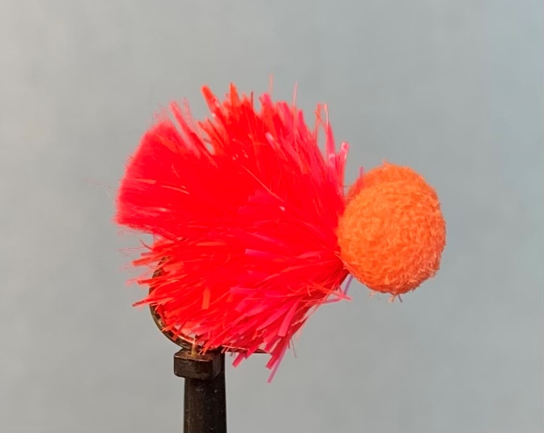

Materials:

Short shank size 8 bronze (Fario Competition Special FBL 302); orange thread; glo-brite no 4 tag; FNF Block- Jelly hot coral front half; FNF Block-Jelly Magma rear half; 5.5/6mm orange booby foam eyes.

Tying Instructions:

1. Place the hook in the vice and run the thread down in touching turns to the bend.
2. Take a good length of the floss and double it over 5 times to create the tail.
3. Tie the tail in on top of the shank with 3 tight turns then snip off the waste at an angle then bind down the waste ends with the thread towards the eye. Return the thread to the tail.
4. Trim the tail to length and brush out.
5. Prepare a length of the block-jelly magma fritz by removing the loose fibres to expose the core and tie this in take the thread up the shank not quite halfway.
6. Wet the fritz fibres and wind in tight turns up the shank sweeping the fibres back as you go and tie off with one tight turn of thread then remove the waste fibres to expose the core. Tie this in then bring the thread back to the fritz.
7. Prepare a length of the hot coral fritz in a similar manner to the magma and tie this in, then wind the thread to 3mm back from the eye.
8. Moisten the fritz then wind in tight turns towards the thread sweeping back the fibres as you go.
9. Finish the coral fritz at the thread position and catch it in with 1 tight turn to secure the fritz. Cut the fritz waste back from the end so that all the loose fibres can be stripped away to expose the core that can then be tied in.
10. Pulling any stray fritz fibres back bind the thread up to the eye and back to form a level base for the booby eyes.
11. Place the already prepared booby eyes on top of the thread (a smear of super glue can help to stop the booby eyes from rotating around the shank) parallel to the shank and take 1 full turn of thread around the centre of eyes and hook and check for position.
12. When you are happy that everything is ok turn the eyes crosswise to the shank and wind the thread in figure of eight turns to secure the eyes.
13. When the eyes are secure whip finish the thread at the eye, trim and varnish the thread.
14. If accessing the hook eye is difficult due to the position of the booby eyes you can whip finish behind the eyes by applying some varnish to the thread beforehand.