**CHILTERN FLY TYING & FLY FISHING**

**RED LEGGED HEATHER FLY**

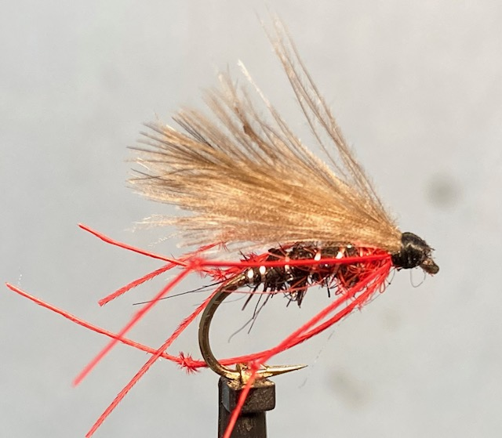

Materials:

Light wire hook size 10-14; black thread; thin silver wire rib; black seals fur mix; red seal’s fur; red cock pheasant tail hopper legs; natural CDC feathers; Liquid flotant. **Optional,** Coch-y-bondu/Furnace hen hackle.

Tying Instructions:

1. Place the hook in the vice, tie in the thread at the eye then wind a foundation to start of the bend.
2. Catch in a length of silver wire and then ‘dub’ the seal’s fur mix onto the thread and wind a tight body to approximately 3/5 of the body.
3. Remove any excess black fur and dub on the red seal’s fur and wind this to approximately 2mm back from the eye.
4. Trim any stray seal’s fur fibres then wind a ribbing of the silver wire in open even spirals. Tie off and remove the wire.
5. Take 3 red hopper legs and tie in on one side slightly sloping down.
6. Turn the hook over and tie in 3 more legs to match.
7. Select 4 light coloured natural CDC feathers and place 2 back to back with tips aligned, then place one either side of this pair back to face with all 4 feather tips aligned.
8. Offer this up to the shank and tie in with a few pinch and loops so the wing sits on top of the shank and just longer than the body and tie in at this position.
9. Check for position then bind down to secure.
10. Trim the waste CDC stalks and wind a head and whip finish and varnish.

**Alternatively: To change the fly to a pulling hopper**

1. Omit the whip finish etc. and prepare the tip of a suitable sized hen hackle with fibres at least 1 ½ the hook gape.
2. Tie this in by the tip good side down. Holding the stalk with hackle pliers pull up vertically and stroke the hackle fibres either side of the stalk to ‘double’ the hackle. Wind this in 3 full turns stroking back the fibres with each turn.
3. Tie off the hackle and secure with tight turns of thread. Trim the stalk.
4. Finally whip finish and varnish the head.
5. When dry apply a thin smear of liquid flotant.