HOPPER

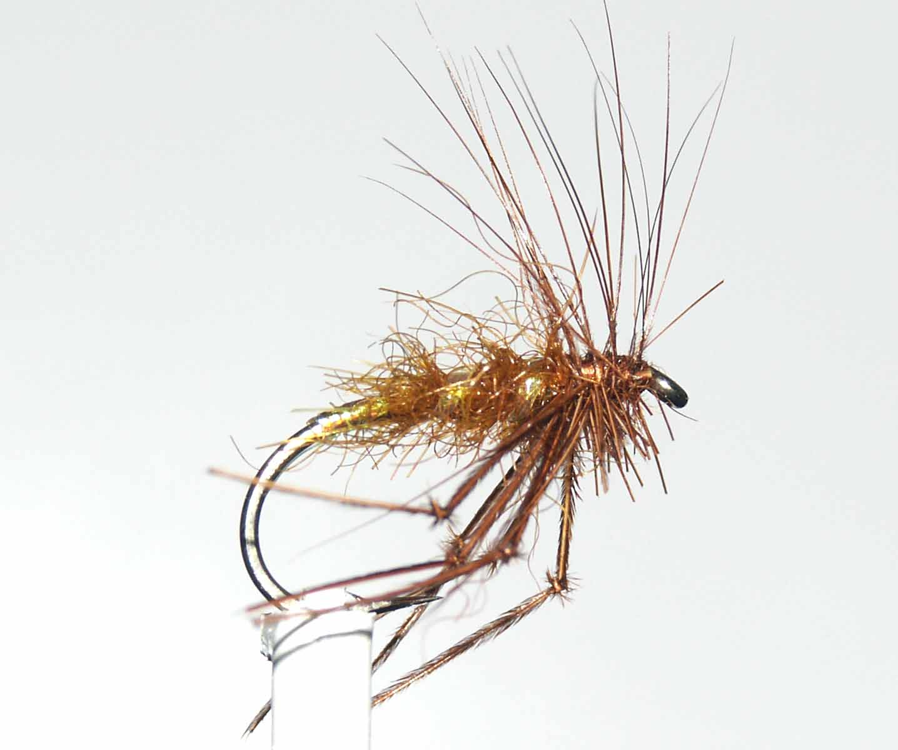

Material
Light wire hook 10-14, suitable coloured thread, seals fur and cock hackles to match, flat pearl tinsel, cock pheasant centre tail fibres,

Tying Sequence

- Tie on the thread and catch in a suitable length of flat pearl tinsel and continue to wind the thread down past the bend, binding in the tinsel as you go.
- Return the thread to the start of the bend and wind the tinsel as a tag up to this point. Tie off at this point but do not trim away the tinsel.
- Dub the seal’s fur onto the thread and wind a tapered body trapping in as many of the seal’s fur fibres as you can and finish approx 4mm back from the eye.
- Rib the body with the remaining tinsel and tie off at the end of the dubbing and trim the waste.
- Prepare the legs by knotting the pheasant tail fibres and tie in 3 legs either side of the shank so that they hang beneath the shank
- Bind down and trim the stalks and tie in a suitable cock hackle by the base of the feather concave side facing towards the eye.
- Wind the hackle forward and bring the thread in open turns through the hackle and tie off and trim.
- Finally whip finish and varnish the head and trim the fibres from beneath the fly, also trim the legs if they are too long.

