**CHILTERN FLY TYING & FLY FISHING**

**BLUE WINGED OLIVE SPINNER**

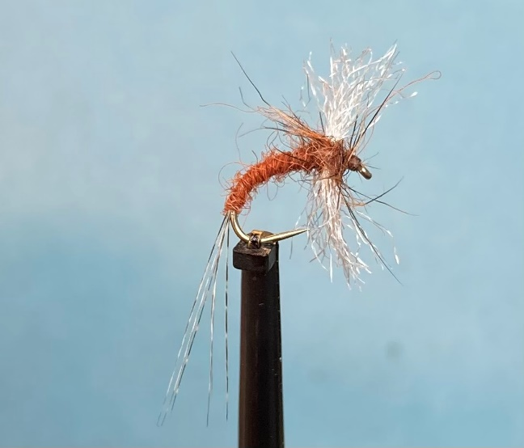

Materials:

Caddis emerger hook size 14 (Grip 14711BL); brown /rust thread; coq de leon tail; rusty coloured dubbing; Sculpting Flash Fibre (Pearl?) wing; rusty dubbing and fox squirrel guard hair thorax

Tying Instructions:

1. Place the hook in the vice and run the thread down the shank and half way round the bend then half way back
2. Pull 5 or 6 fibres coq du leon fibres out from the shank and align the tips then pull off from the stalk.
3. Tie in the tail fibres on top of the shank very long then continue winding to half way round the bend. Wind the thread back trapping the waste and trimming at the thorax. Return the thread to half way round the bend.
4. Dub on the rusty dubbing and catch it in before tightening the dubbing so you can form a slim body up to the thorax position.
5. Take the wing material and melt the ends to stop stray fibres from being trapped when tying the rest of the fly.
6. The wing has to be tied in at the thorax position not across the shank but up and down. (If you have a rotary vice this is made easier if you rotate the vice by 90 degrees). Figure of eight wrap the thread to secure the wing.
7. Mix some darker spiky dubbing with the body dubbing to form the material for the thorax then dub this onto the thread.
8. Figure of eight wind the dubbing around the base wing and finish at the eye.
9. Remove any remaining dubbing before whip finishing and varnishing the head
10. Gauge the length of the body with scissor tips and trim the wing filaments to this length.